**LinguoInsight: A Novel LDA-Based Textbook Comprehension Model to improve the acquisition skills of learners**

**Abstract:** In diverse educational settings, students face challenges in fully comprehending the context of textbooks. Addressing this, our research introduces an innovative unsupervised topic modeling approach, LDA, to unravel latent topics within lessons across various subjects and curricula. The exploratory analysis reveals significant keywords, co-occurrence patterns, and correlations, contributing to improved comprehension and acquisition skills. Recognizing the universal demand for effective learning tools, our work demonstrates that learners globally express eagerness to embrace the NLP technology-driven topic modeling approach. This signifies a crucial step towards overcoming challenges in textbook comprehension and fostering a more engaging and efficient learning environment across diverse educational contexts. A prototype mobile app, integrating LDA-based topic modeling, is developed and tested with educators globally. The study explores the potential and challenges of integrating LDA-extracted content into mobile apps for universal learning enhancement. Feedback analysis, sentiment estimation, and user engagement affirm the applicability and enthusiasm for this NLP-driven approach in teaching and learning across disciplines.

**Keywords:** Natural Language Processing (NLP), Topic Modeling, Latent Dirichlet Allocation (LDA), Exploratory Analysis, Textbook Learning, Coherence

**Author information**

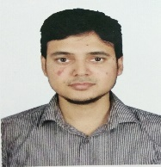

Dr. Md Iftekharul Mobin, Assistant Professor, Computer Science, D219,

American International University-Bangladesh (AIUB)

[iftekhar.mobin@aiub.edu](mailto:iftekhar.mobin@aiub.edu), ORCID ID 0000-0002-3065-2486

D Building, 408/1, Kuratoli, Khilkhet, Dhaka 1229, Bangladesh

Dr. Md Iftekharul Mobin (Member, IEEE) is an Assistant Professor of the Faculty of Science and Technology at American International University-Bangladesh (AIUB). His research interests are NLP, time-series prediction, health informatics, IoT, Image processing etc. Dr. Iftekharul Mobin awarded Ph.D from Queen Mary University of London and received B.Sc. from Islamic University of Technology (IUT). Awarded Queen Mary and ImpactQM scholarship for industry-academia partnership during his doctoral studies. He received funding from Bangladesh's ICT ministry and several other collaborative research activities. He has work experience as a software engineer in UK, Japan, and Bangladesh for 4+ years. His experiences are therefore mixed across the academic and software industries. He has served as a program committee member, editor, and reviewer for various conferences and journals worldwide. He can be contacted at iftekhar.mobin@aiub.edu

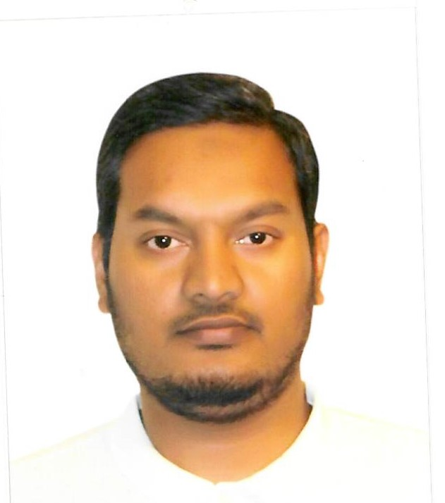

[suaibakhter@subu.edu.tr](mailto:suaibakhter@subu.edu.tr>)

A. F. M. Suaib Akhter, Department of Computer Engineering, Sakarya University of Applied Sciences, Sakarya, Serdivan, Turkey.   
  
A. F. M. Suaib Akhter (Member, IEEE) received the Ph.D. degree from the Department of Computer and Information Engineering, Sakarya University, Turkey, in 2021. He is currently working as a Lecturer with the Sakarya University of Applied Sciences. He is also involved in several projects related to distributed systems and the Internet of Things (IoT). His research interests include blockchain technology, the IoT, wireless communications, vehicular ad hoc networks, intelligent vehicles, network security, distributed systems, and machine learning. He is also serving as an Associate Editor for the Journal of Cyber Security Technology (Taylor & Francis) and a guest editor for many special issues of different journals.

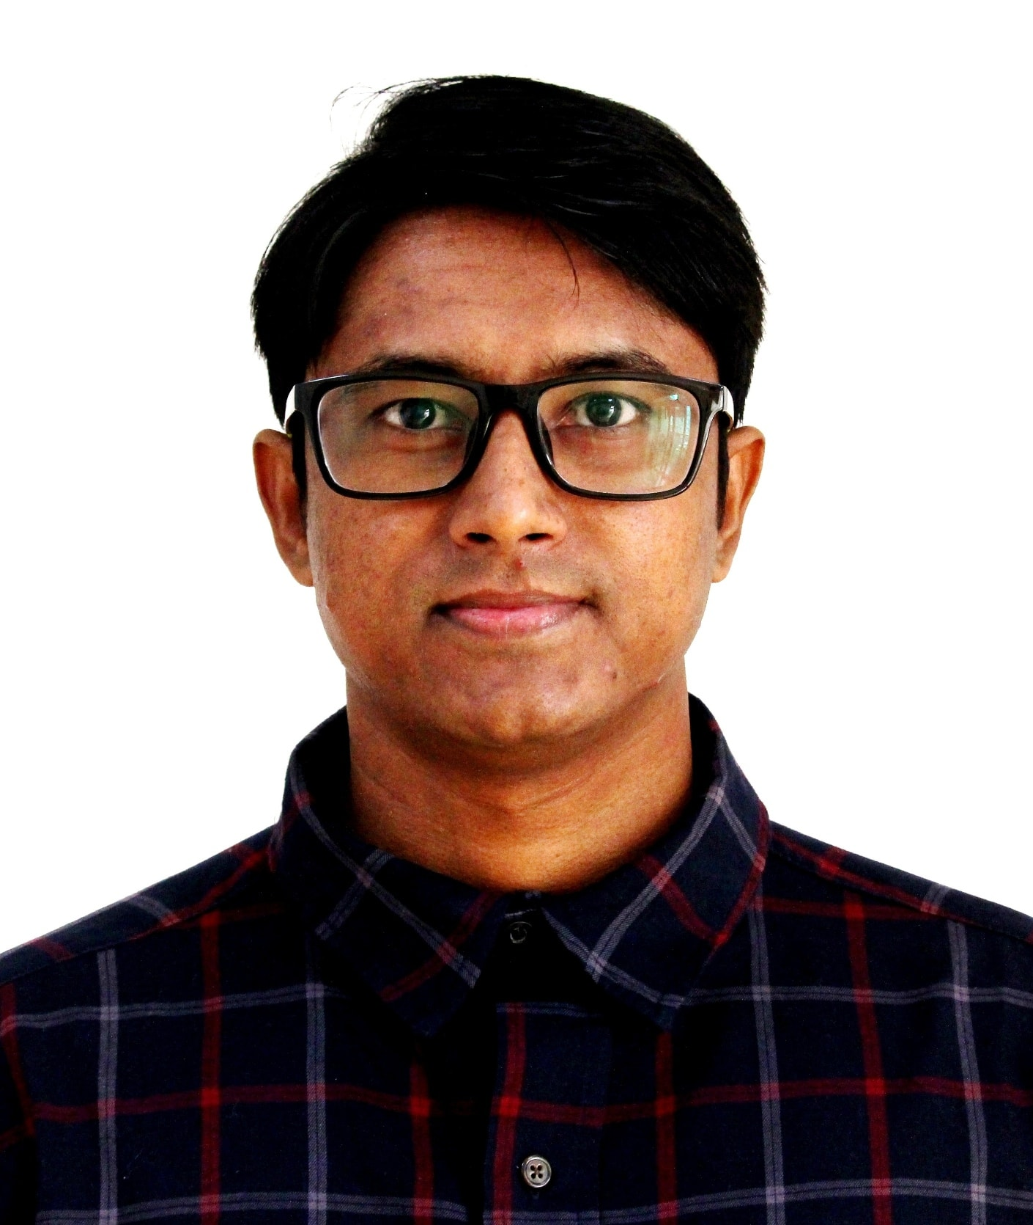

Dr. S. M. HASAN MAHMUD, Assistant Professor, Computer Science, D217,

American International University-Bangladesh (AIUB)

[hasan.swe@aiub.edu](mailto:hasan.swe@aiub.edu), ORCID ID 0000-0002-6828-3559

D Building, 408/1, Kuratoli, Khilkhet, Dhaka 1229, Bangladesh

Dr. Mahmud is currently serving as an Assistant Professor in the Computer Science Department at American International University-Bangladesh (AIUB) in Dhaka, Bangladesh. His research interests primarily include machine learning and health informatics using Big Data analytics technologies. He has authored or co-authored approximately 60 journal and conference papers (Total IF: 150). Dr. Mahmud has served as a program committee member, track chair, session chair, editor, and reviewer for various conferences and journals worldwide. He has received several awards, including the Best Paper Award and the 2nd position in the Best Academic and Research Award-UESTC. Furthermore, he has actively participated in organizing international conferences. Dr. Mahmud currently holds the position of Director at the Centre for Advanced Machine Learning and Applications, where researchers and professors collaborate from the USA, Australia, Sweden, China, and Bangladesh. Email: hasan.swe@aiub.edu

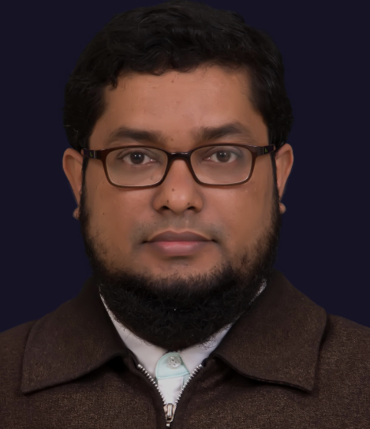

Md. Golam Rabiul Alam, PhD, Professor

Building-8, Floor-9th, Room no. UB80903, 45 Mohakhali C/A, Dhaka-1212

[rabiul.alam@bracu.ac.bd](mailto:rabiul.alam@bracu.ac.bd)

ORCID ID: 0000-0002-9054-7557

Md. Golam Rabiul Alam is a Professor of Computer Science and Engineering Department of BRAC University. He received Ph.D. in Computer Engineering from Kyung Hee University, South Korea in 2017. He served as a Post-doctoral researcher in Computer Science and Engineering Department, Kyung Hee University, Korea from March 2017 to February 2018. Dr. Rabiul Alam received B.S. and M.S. degrees in Computer Science and Engineering, and Information Technology from Khulna University and University of Dhaka respectively.   Dr. Rabiul Alam has published around 70 research articles in reputed journals, and conference proceedings. He has also 3 registered patents on ambient assisted living, mobile cloud computing and mobile fog computing, respectively. He is the reviewer of IEEE Communications Magazine, IEEE Transactions on Network and Service Management, IEEE Access, Elsevier Journal on Vehicular Communications, Elsevier Journal of Systems Architecture, IEEE/IFIP IM (International Symposium on Integrated Network Management), and IEEE/IFIP NOMS(Network Operations and Management Symposium), IEEE ICC (International Conference on Communications), IEICE/KICS APNOMS (Asia-Pacific Network Operations and Management Symposium), KIISE ICOIN (International Conference on Information Networking), ECCE (International Conference on Electrical, Computer and Communication Engineering), ACM ICUIMC (International Conference on Ubiquitous Information Management and Communication-IMCOM), and TPC member of ICCA (International Conference on Computer and Applications, UAE).  Dr. Rabiul Alam's research interests include Healthcare-IoT networks, Mental-health informatics, Ambient intelligence systems, Mobile-cloud computing, Edge computing, Affective computing, and UAV Image processing.  He is a member of the IEEE Computer Society, Consumer Electronics Society, and Industrial Electronics Society and  received several best paper awards at  national and international research conferences.

**Conflict of Interest – None**

There is hereby declare that there is not any Conflict of Interest.